Tuan Nguyen

ReadMe

The project consists of IOCS functions and an User Interface to experiment with it
+) create:
-search for file in root directory, if already exist generate error
-else: create an entry, update Dir Table, update FAT, add the filename to the current
directory block
-if the file is a directory, update currentDir to indicate we are in the directory after
creation
+) delete:
-search for file in root directory, if not exist, generate error
-remove entry from dir Table
-Update FAT and the filename in current directory block
+) open:
-find the first block of the file
+) close: -go back to root directory
+) read: -from the 1st block, navigate all the other blocks and read it into a buffer
+) write: -from the 1st block, navigate to the last block, find new empty block to inser
data, then update FAT, meta data.

Project Execution:
-press make and ./serv and the user interface will pop up

Result and Test case:
Run:
-make
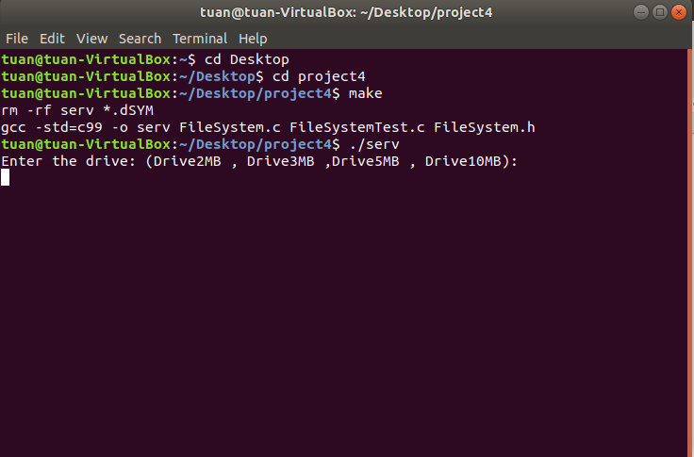
-./serv

Select the drive:
For example: Drive2MB
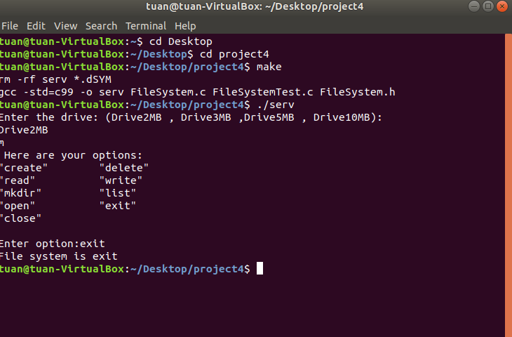

Drive5MB

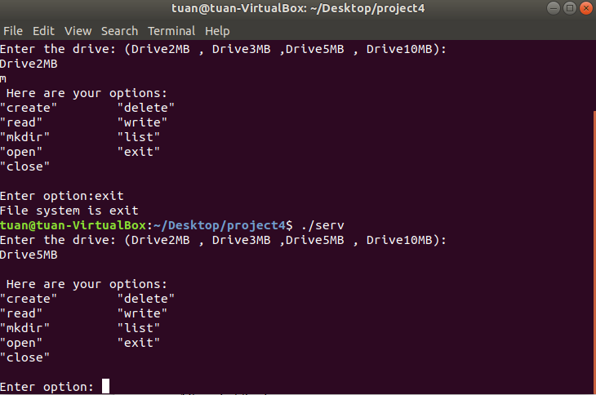

List root directory: empty because we didn’t create or make any file yet.
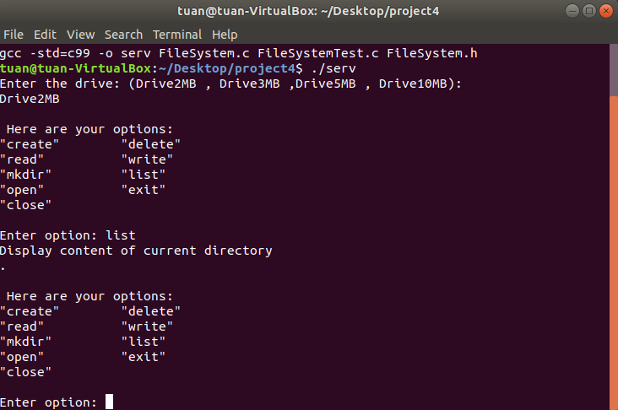
Create a file: text_file_1 under root directory
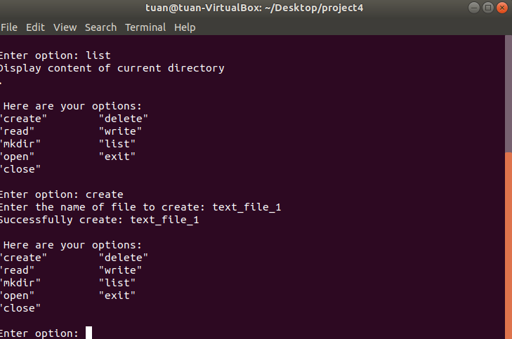

write to file: text_file_1 word: hello world

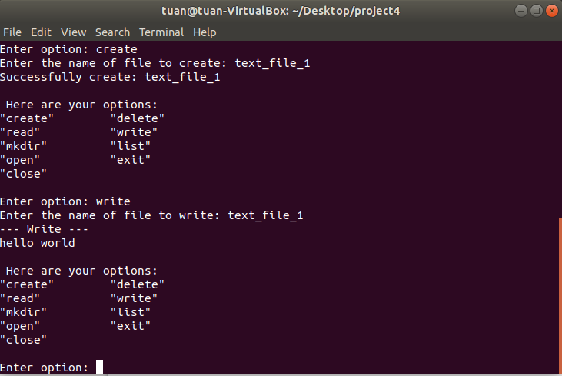

create another file : text_file_2

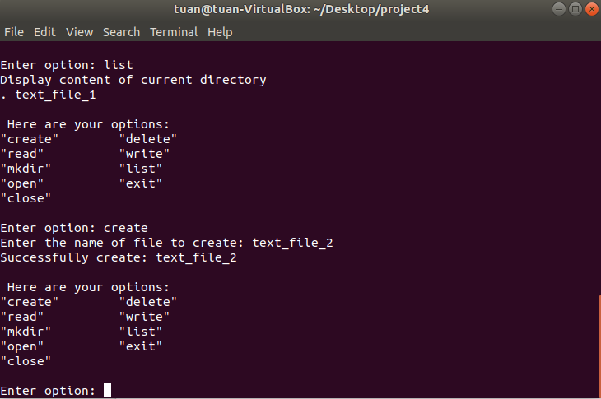

write to text_file_2 word : the world

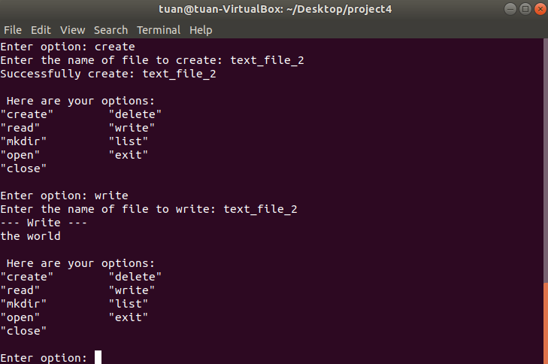

Create sub-directory name: sub-dir

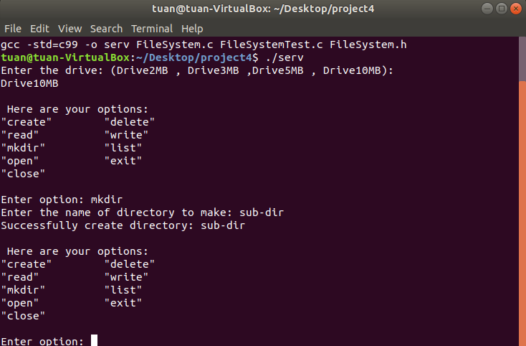

List content in sub-dir after text_file_2 created
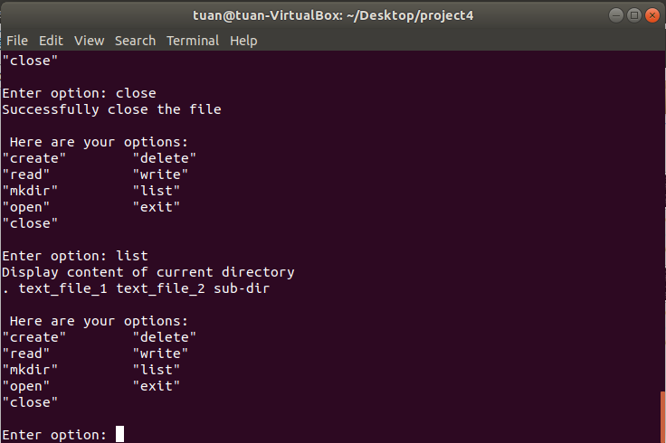

Close virtual disk and exit

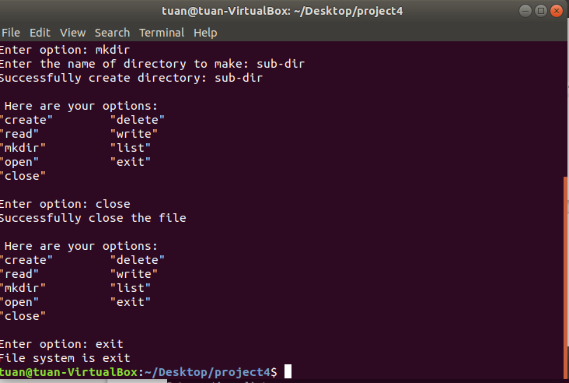

open text_file_1 and print context to screen
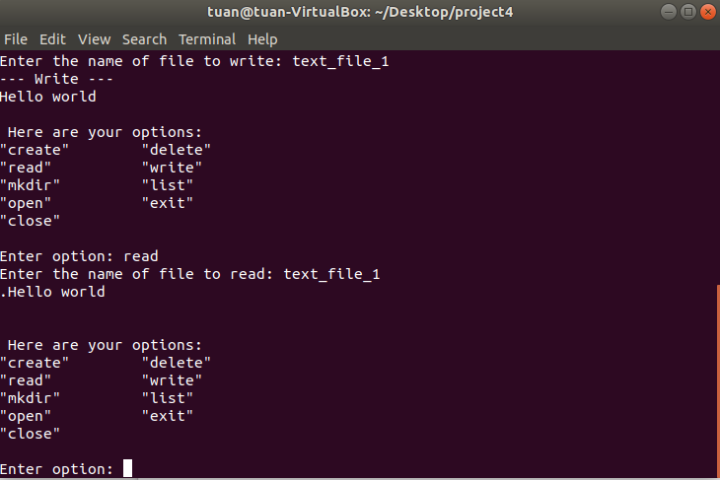

Delete text_file_2

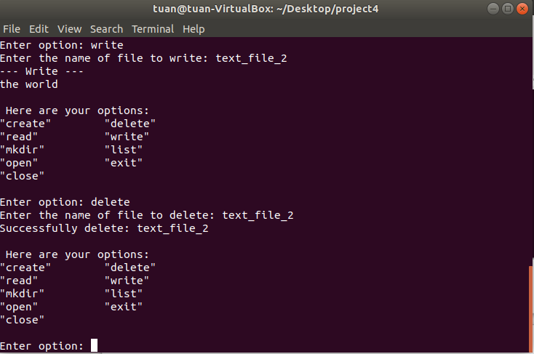

Print out directory hierarchy again, we see that text_file_2 not appear because it has been previous delete
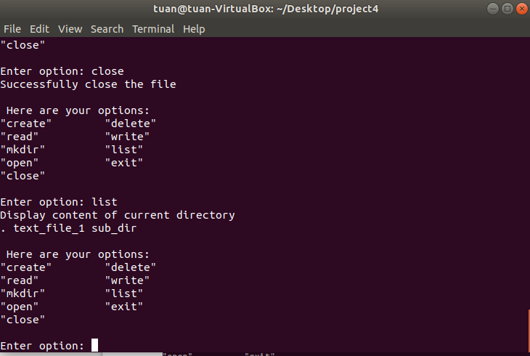

See hexdump of disk drive
